Ideation Phase
Brainstorm & Idea Prioritization Template

Date | 26 November 2025
Team ID
Project Name | Bookstore
Maximum Marks | 4 Marks

Brainstorm & Idea Prioritization Template:
Brainstorming provides a free and open environment that encourages everyone in a team to participate in the creative thinking process that leads to problem solving. By focusing on volume over value, out-of-the-box ideas are welcomed, built upon, and refined. Team members collaborate to explore multiple solution paths, ultimately shaping a rich set of innovative concepts for the project.
Step-1: Team Gathering, Collaboration and Select the Problem Statement
Based on earlier analysis and customer problem statements, the selected core problem for the Bookstore project is:

Selected Problem Statement
Users struggle to search, filter, and discover books efficiently due to limited search features, cluttered interfaces, and lack of personalized tools such as wishlists, reviews, and recommendations.

Key Supporting Issues Identified
- Complex or inconsistent search results
- No proper filtering by genre, author, rating
- Poor wishlist and cart organization
- Lack of genuine user reviews
- Admin panel limitations for book management
This becomes the main problem that the solution will address.

Step-2: Brainstorm, Idea Listing and Grouping
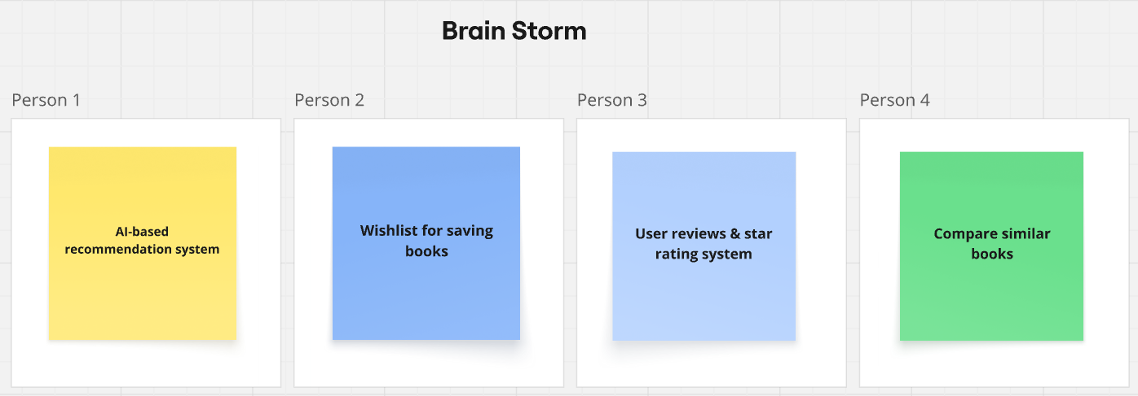

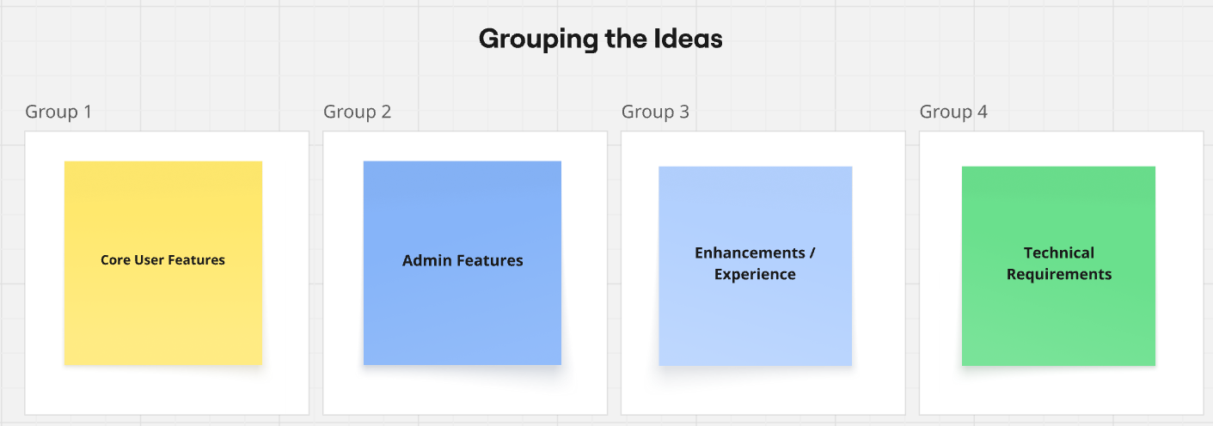

Step-3: Idea Prioritization
